Steps of creating Virtual Environment of jupyter notebook

* conda create --name testingopenai

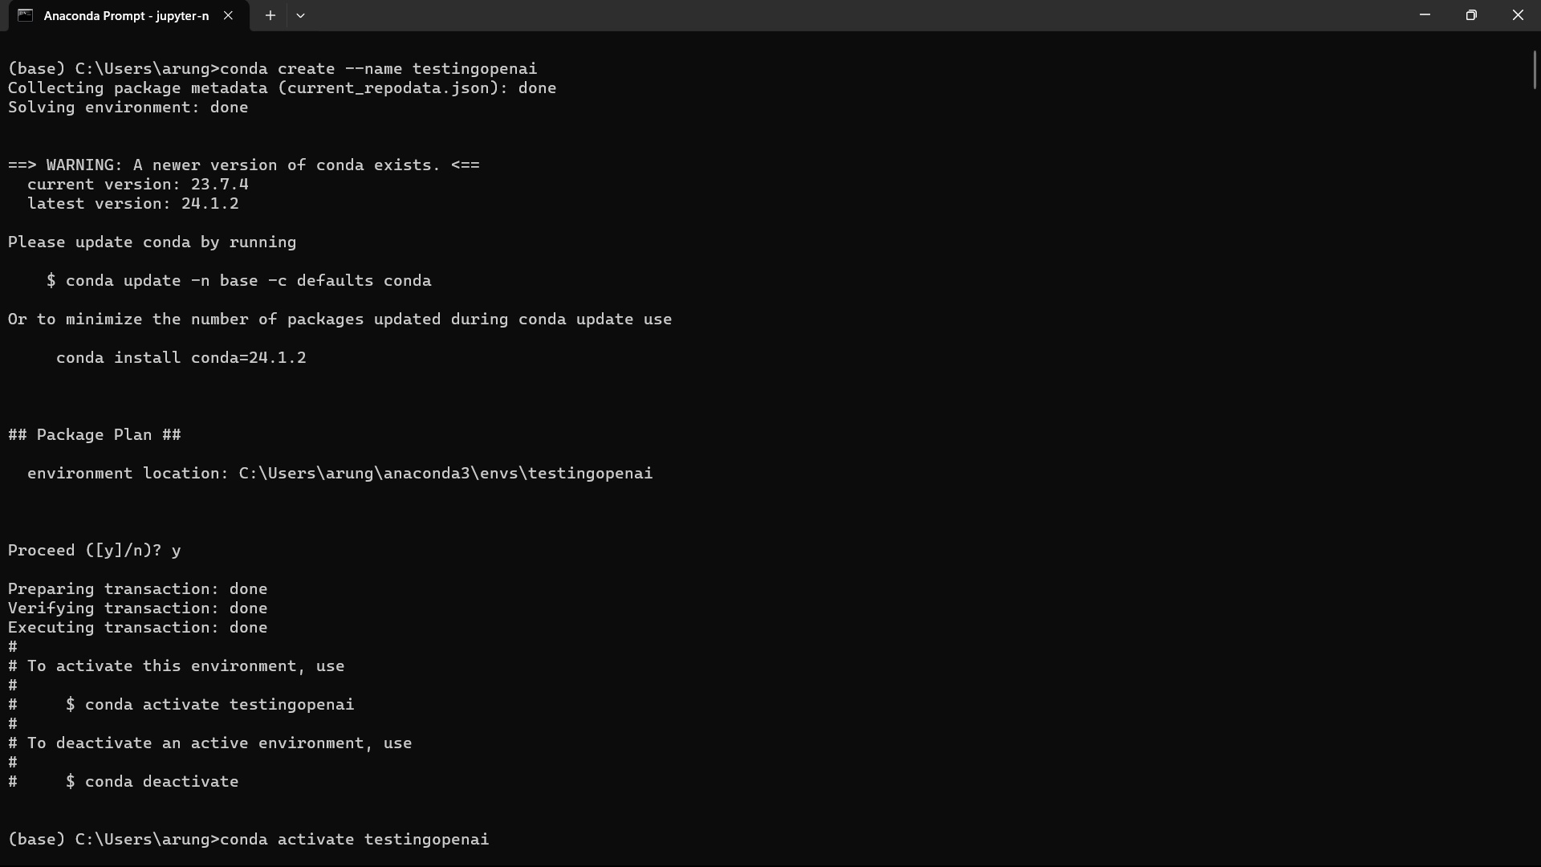

* conda activate testingopenai

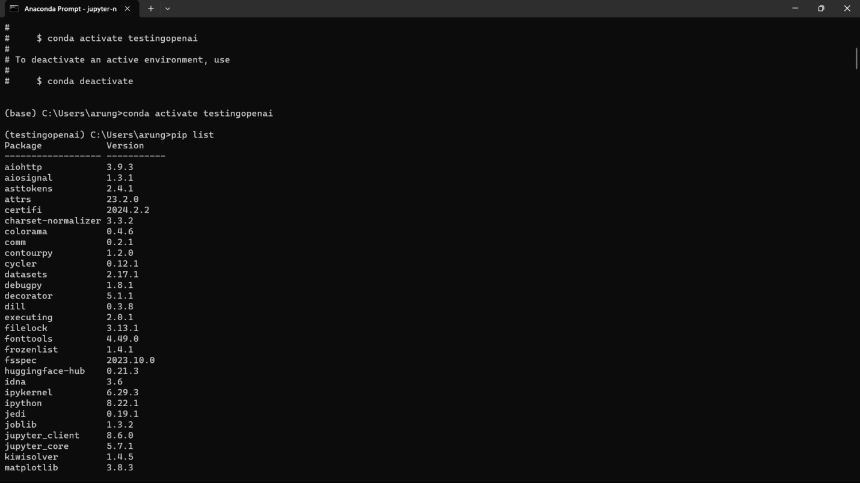

* pip install jupyter notebook

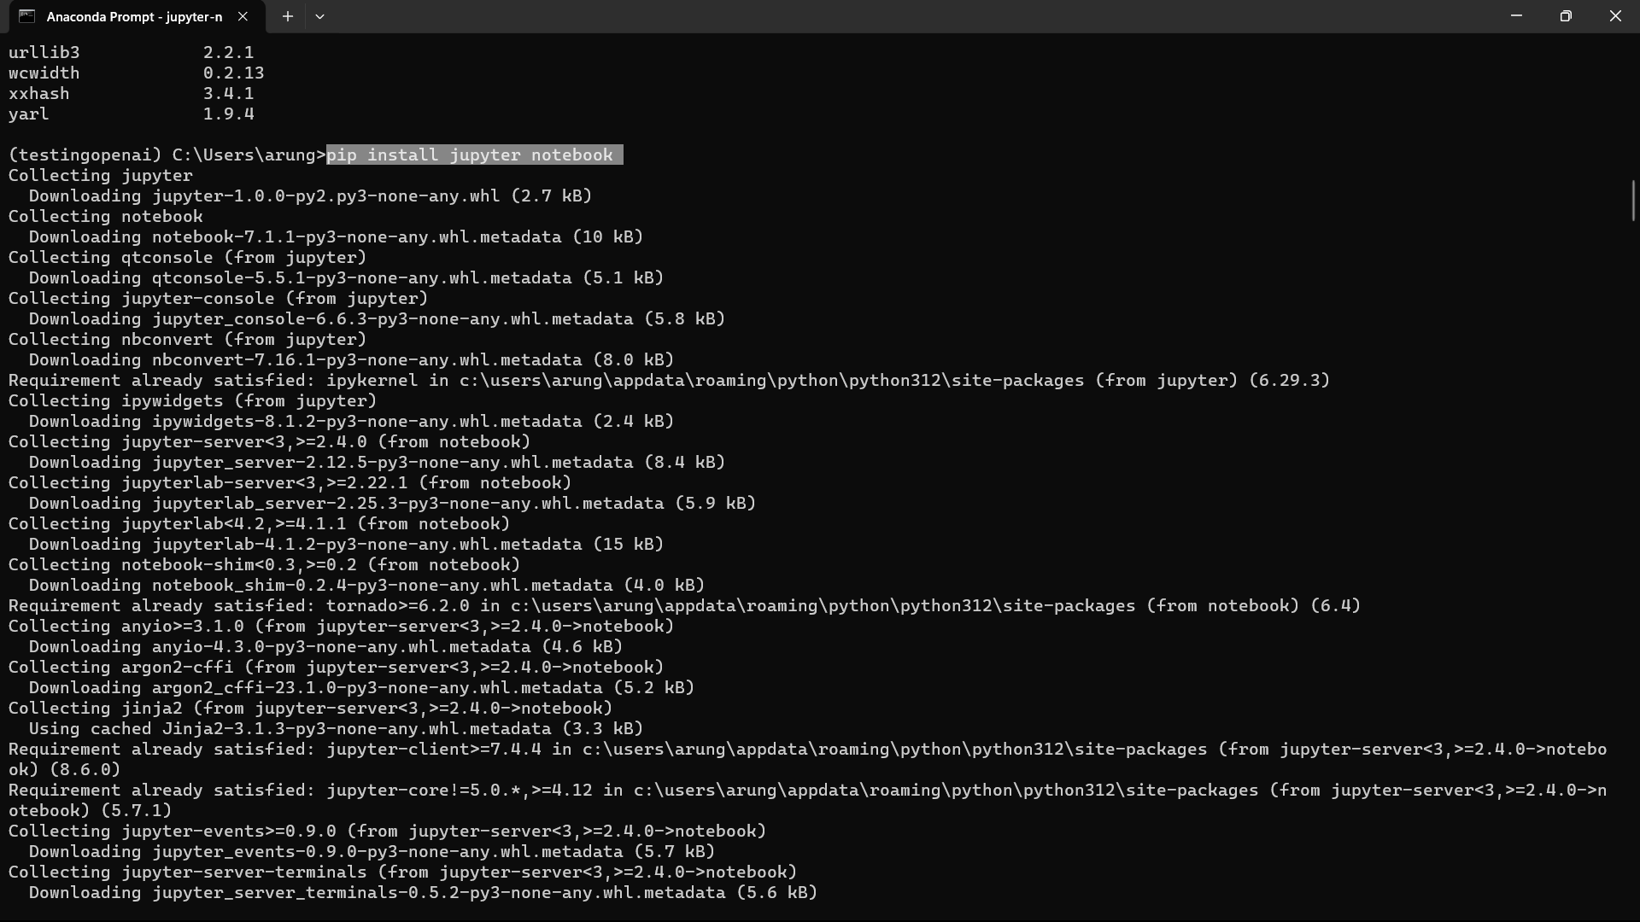

* pip list which helps to see list of install lib
* jupyter-notebook to open notebook

